NAME : MOHAN.L
REG.NO.192521103
COURSE : ARTIFICIAL INTELLIGENCE
CODE : CSA1717
DATE:09/10/2026

Lab Python Programs (List 1)
- Write a python program to solve 8 puzzle problem

from heapq import heappush, heappop

start = (1, 2, 3,
4, 0, 6,
7, 5, 8)

goal = (1, 2, 3,
4, 5, 6,
7, 8, 0)

def heuristic(state):
return sum(state[i] != 0 and state[i] != goal[i]
for i in range(9))

def solve(start):
pq = []
heappush(pq, (heuristic(start), 0, start, []))
visited = set()

while pq:
f, g, state, path = heappop(pq)

if state in visited:
continue
visited.add(state)

path = path + [state]

if state == goal:
for s in path:
for i in range(0, 9, 3):
print(s[i:i+3])
print()
return

z = state.index(0)
r, c = divmod(z, 3)
for dr, dc in [(1, 0), (-1, 0), (0, 1), (0, -1)]:
nr, nc = r + dr, c + dc
if 0 <= nr < 3 and 0 <= nc < 3:
nz = nr * 3 + nc
new = list(state)
new[z], new[nz] = new[nz], new[z]
new = tuple(new)
if new not in visited:
heappush(pq, (g + 1 + heuristic(new),
g + 1, new, path))

solve(start)

Output:
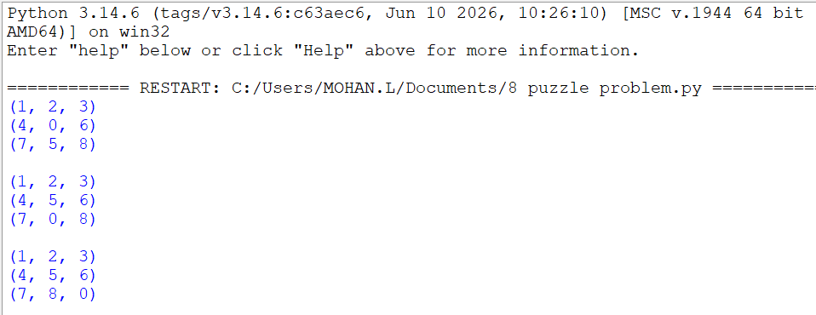
- Write a python program to solve 8 Queen problem

def solve(board, row):
if row == 8:
for r in board:
print(" ".join("Q" if x else "." for x in r))
return True

for col in range(8):
safe = True

for r in range(row):
if (board[r][col] or
(row - r == abs(col - board[r].index(1)))):
safe = False
break

if safe:
board[row][col] = 1

if solve(board, row + 1):
return True

board[row][col] = 0

return False

board = [[0] * 8 for _ in range(8)]
solve(board, 0)

Output
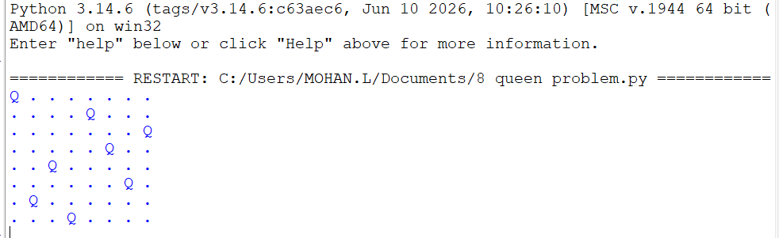

- Write a python program for water jug problem

from collections import deque

def water_jug():
start = (0, 0)
goal = 2
queue = deque([(start, [])])
visited = set()

while queue:
(a, b), path = queue.popleft()

if (a, b) in visited:
continue
visited.add((a, b))

path = path + [(a, b)]

if a == goal or b == goal:
for state in path:
print(state)
return

states = [
(4, b), (a, 3), (0, b), (a, 0),
(a - min(a, 3 - b), b + min(a, 3 - b)),
(a + min(b, 4 - a), b - min(b, 4 - a))
]

for state in states:
if state not in visited:
queue.append((state, path))

water_jug()

Output
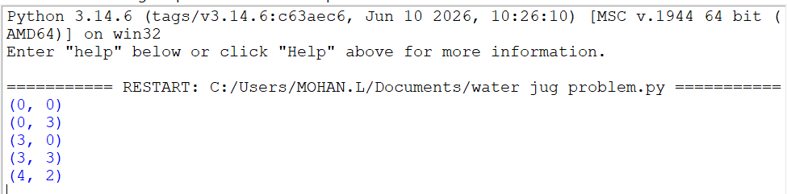

- Write a python program to solve cript arithmetic problem

from itertools import permutations

letters = "SENDMORY"

for p in permutations(range(10), len(letters)):
d = dict(zip(letters, p))

if d['S'] == 0 or d['M'] == 0:
continue

SEND = d['S']*1000 + d['E']*100 + d['N']*10 + d['D']
MORE = d['M']*1000 + d['O']*100 + d['R']*10 + d['E']
MONEY = d['M']*10000 + d['O']*1000 + d['N']*100 + d['E']*10 + d['Y']

if SEND + MORE == MONEY:
print("SEND =", SEND)
print("MORE =", MORE)
print("MONEY =", MONEY)
break

Output
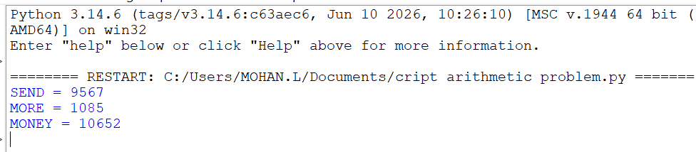

- Write the python program for Missionaries Cannibal problem

from collections import deque

def solve():
start = (3, 3, 1)
goal = (0, 0, 0)

queue = deque([(start, [])])
visited = set()

moves = [(1, 0), (2, 0), (0, 1),
(0, 2), (1, 1)]

while queue:
state, path = queue.popleft()

if state in visited:
continue
visited.add(state)

path = path + [state]

if state == goal:
for s in path:
print(s)
return

m, c, boat = state

for dm, dc in moves:
if boat == 1:
nm, nc, nb = m - dm, c - dc, 0
else:
nm, nc, nb = m + dm, c + dc, 1

if not (0 <= nm <= 3 and 0 <= nc <= 3):
continue

mr, cr = 3 - nm, 3 - nc

if ((nm == 0 or nm >= nc) and
(mr == 0 or mr >= cr)):
new_state = (nm, nc, nb)

if new_state not in visited:
queue.append((new_state, path))

solve()

Output
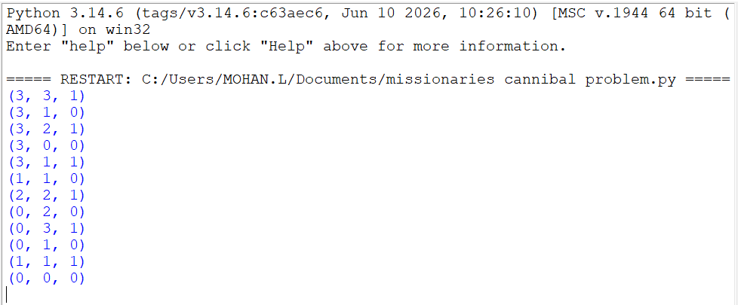

- Write the python program for Vacuum Cleaner problem

rooms = {'A': 1, 'B': 1}
location = 'A'

while 1:
print("Location:", location)

if rooms[location] == 1:
print("Room is Dirty. Cleaning...")
rooms[location] = 0
else:
print("Room is Clean.")

if location == 'A':
location = 'B'
else:
location = 'A'

if rooms['A'] == 0 and rooms['B'] == 0:
print("All rooms are clean!")
break

Output
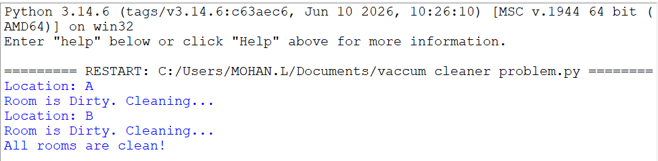
- Write the python program to implement BFS.

from collections import deque

graph = {
'A': ['B', 'C'],
'B': ['D', 'E'],
'C': ['F'],
'D': [],
'E': [],
'F': []
}

def bfs(start):
visited = set()
queue = deque([start])

while queue:
node = queue.popleft()

if node not in visited:
print(node, end=" ")
visited.add(node)
queue.extend(graph[node])

bfs('A')

Output
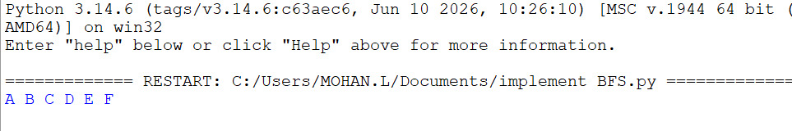

- Write the python program to implement DFS

graph = {
'A': ['B', 'C'],
'B': ['D', 'E'],
'C': ['F'],
'D': [],
'E': [],
'F': []
}

visited = set()

def dfs(node):
if node not in visited:
print(node, end=" ")
visited.add(node)

for neighbour in graph[node]:
dfs(neighbour)

dfs('A')

Output
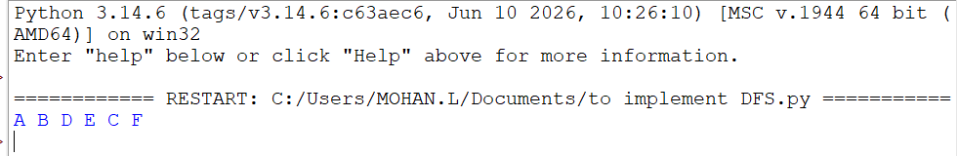

- Write the python to implement Travelling Salesman Problem

from itertools import permutations

dist = [
[0, 10, 15, 20],
[10, 0, 35, 25],
[15, 35, 0, 30],
[20, 25, 30, 0]
]

n = len(dist)
cities = range(1, n)
min_cost = float('inf')
best_path = None

for path in permutations(cities):
route = (0,) + path + (0,)
cost = sum(dist[route[i]][route[i+1]]
for i in range(n))

if cost < min_cost:
min_cost = cost
best_path = route

print("Best Path:", best_path)
print("Minimum Cost:", min_cost)
Output
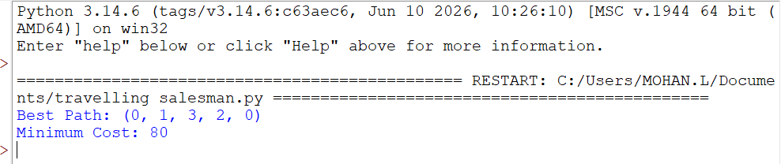

- Write the python program to implement A* algorithm

graph = {
'A': [('B', 1), ('C', 3)],
'B': [('D', 3), ('E', 1)],
'C': [('F', 5)],
'D': [],
'E': [('F', 2)],
'F': []
}

h = {'A': 6, 'B': 4, 'C': 5,
'D': 3, 'E': 2, 'F': 0}

def astar(start, goal):
open_list = [(h[start], 0, start, [start])]
visited = set()

while open_list:
open_list.sort()
f, g, node, path = open_list.pop(0)

if node == goal:
print("Path:", path)
print("Cost:", g)
return

if node in visited:
continue
visited.add(node)

for neighbour, cost in graph[node]:
if neighbour not in visited:
new_g = g + cost
new_f = new_g + h[neighbour]
open_list.append(
(new_f, new_g, neighbour,
path + [neighbour])
)

astar('A', 'F')

Output


